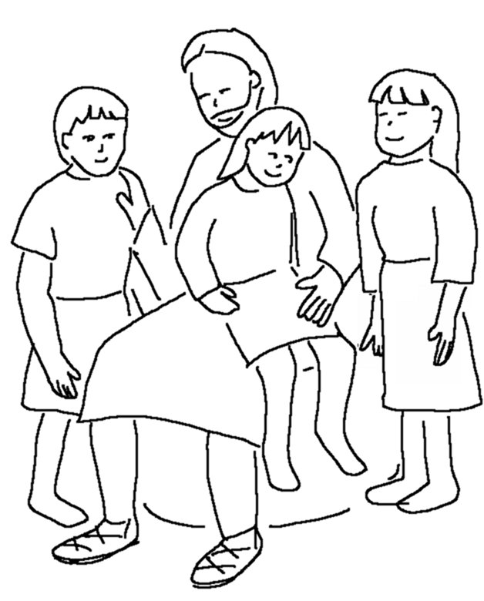
When everything is ready,
I will come and get you, so that you will always be with me where I am.
John 14:3_{NLT}

